RNN stands for Recurrent Neural Network.
RNN is a sequential model that works for sequential data.
Example of sequential data:
- Text
- Time Series
- Speech
- DNA sequences

Why cant we use ANN?
- ANN cannot remember the sequence of words
- Varying text, (one data oint has 10 inputs of 10 words, second data point has 5 inputs of 5 words), ANN works only on fixed input size.
- Prediction problem, maximum length of training input is 100 words, but you have 150 words in the text for which you want to do the prediction
- Zero padding (computation expensive)

Applications of RNN:
- Sentiment Analysis
- Next word predictor
- Question Answer Model like BERT NLP
- Image describer, given an image model describe the image in words

RNN:
Sequence contains some meaning, mtlb ky jo bd mn word a rha hai wo phly walay py depend kr rha hai
RNN are special class of neural network jinky pass memory ka feature hota hai, mtlb wo past inputs ko yad rakh paty hain that is why they work great on sequential data.

Form of data in RNN:
(timesteps, input features)

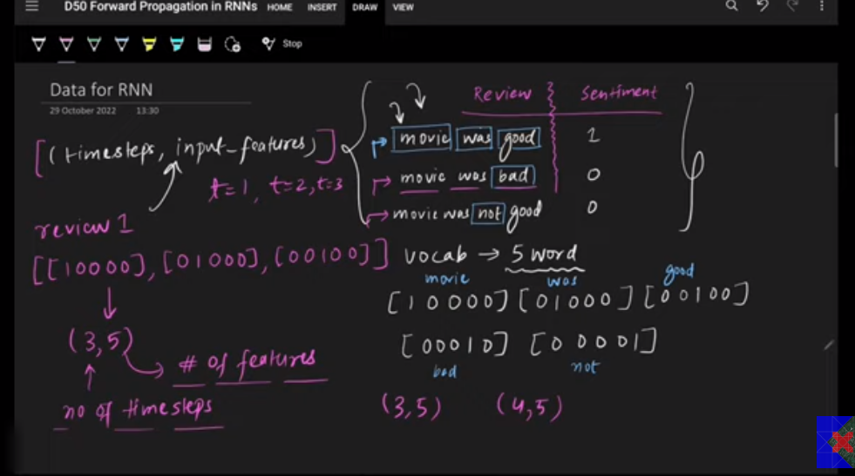

Hr word ki aik vector representation banti hai, jaisay picture mn movie, was, good, bad, not words ka aik vector hai, phly data point mn movie was good that to 3 vector of words, format ye ho ga 3 timesteps and 5 input features, hr word ka aik timestep, or hr word mn 5 features hain, so shape of first data point will be (3,5), for second data point “movie was bad” shape is (3,5), but for third data point “movie was not good” the shape is (4,5) timesteps are 4 because 4 words are there in 3rd review.

SIMPLE RNN FLOW:
KERAS SIMPLE RNN (batch_size(number of data points given at once),timestep,input_features)
Hamara batch size 3 hai, timestep 4 kyn ky sabsy bara review 4 words ka hai or input features 5 kyn ky hr review 5 unique words ka combination hai.
So input tensor shape is (3,4,5)
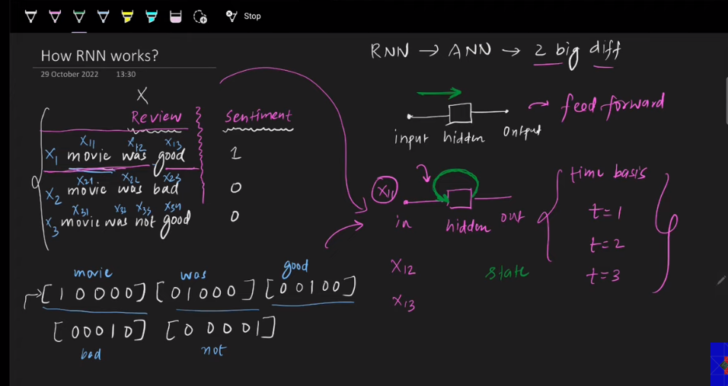
For first review or data point,Jo first input ho ga RNN mn wo x11 ho ga mtlab movie at t=1 or 0, second will be was x12 at t=2 and third will be good x13 at t=3.
Ab RNN jab x11 as a input ly ga to feedback dy ga is input ky baray mn.


